# **INFOSYS320 – Practice Test 1**

For questions 4-6 you should start with the final code from Creative Coding tutorial.

|  |  |  |
| --- | --- | --- |
| 1 | Draw a sketch of the Case | **10** |
| 2 | Draw an Information Model (ERD) of the Case (approximately 15 entities minimum) in Access | **25** |
| 3 | Using the [HoloLens Design Guidance](https://developer.microsoft.com/en-us/windows/mixed-reality/design) describe with diagrams and annotations how you would   * select a truck or other object and display it’s properties (**15**) * show a dashboard/menu to the HoloLens user that moves with them (**15**) | **30** |
| 4 | Make all cubes blue | **5** |
| 5 | Change the colour of one cube every second in the order they were created | **15** |
| 6 | Instead of rotating the cubes place them randomly in the 3D space | **10** |
| 7 | Commit all your work (including your Word document) to Github at least twice and then at the end | **5** |

# Submission

For each step above place a screenshot in a Word document (back up all your work continuously)

Submit your Word document and zipped up Unity3D project to Canvas

Hand in your paper work.

**CASE: Forest Harvesting Information System**

Harvesting a forest involves a constant process of moving resources to places in the forest to cut down trees, load them and then transport them to variety of organisations such as sawmills which transform the raw logs into a wide variety of products or sent directly to ports from where the raw logs are shipped to overseas markets.

This process for, one logging company, is managed by a control centre from which trucks, loaders and crews are dispatched. The people who do this are dispatchers.

Each forest is divided into sub-areas to varying levels of detail. For example, ForestA/1/4/8 or ForestB/26. Within these areas alongside roads are dumps (D1, D2, etc) which is where the crews bring the logs as they cut. At any time, each dump will have a stock of logs which have been categorised into a number of grades. Loaders are sent to the dumps to load trucks which do not have cranes. Trucks may also carry other specialised equipment which is regarded as part of the truck.

Customers place orders for specific numbers of logs of specific grades to be delivered at specified times.

The job of the dispatchers is to optimise this process. Dispatchers have to be able to manage this large and complex set of data making continuous and rapid decisions based on constantly changing circumstances.

The current computer system they use is old and cumbersome and they have asked for a design proposal which will allow them to optimise their operations. The forestry company has heard of HoloLens and see this as potentially central to a new system.

**Question 1: Draw a sketch of the Case**

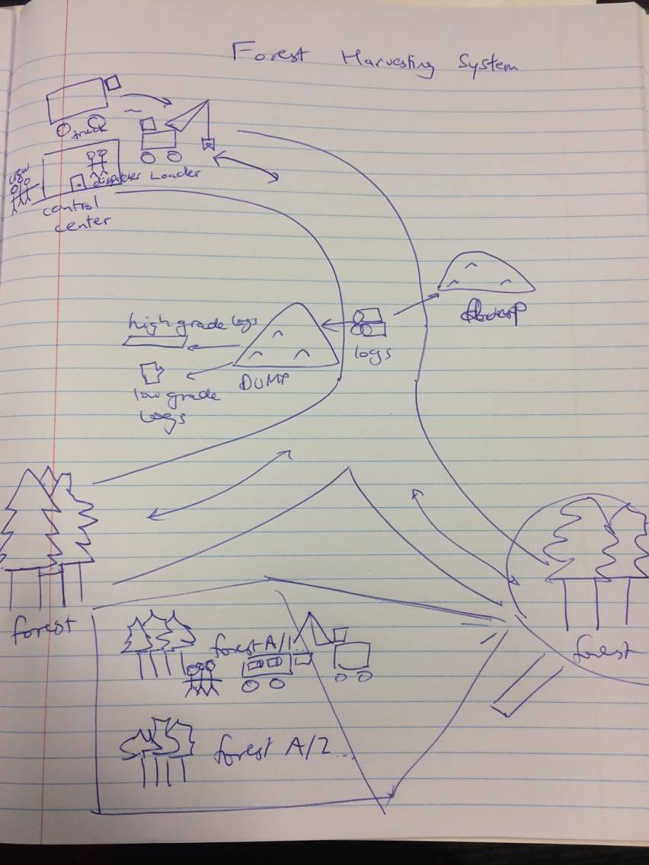

**Question 2: Draw an Information Model (ERD) of the Case (approximately 15 entities minimum) in Access**

**Question 3: Using the** [**HoloLens Design Guidance**](https://developer.microsoft.com/en-us/windows/mixed-reality/design) **describe with diagrams and annotations how you would**

* **select a truck or other object and display it’s properties (15)**
* **show a dashboard/menu to the HoloLens user that moves with them (15)**